EXPECTATIONS OF DDTM STUDENTS & ALUMNI

Honesty, Integrity, Responsibility and Respect are the Reiki Way
Learning is at the centre of the Drawing Down the Moon System of Reiki. We create opportunities for students and apprentices that prepare them for meaningful futures, and active citizenship within our communities and beyond. The Drawing Down the Moon System of Reiki offers a learning environment characterized by encouragement, free thought, integrity, ethics, mutual respect, professionalism, recognition of achievement, and social and ethical responsibility. This cannot be achieved if students choose not to respect the Reiki way and to abide by some basic ethical standards.

Within Drawing Down the Moon System of Reiki training modules
every student has the right to:
- Pursue their Reiki Training in a safe, respectful, and educational environment characterized by the Reiki Precepts of honesty, integrity, respect and hard work.
- Enjoy their Reiki experience in an environment of civility, individual integrity, social responsibility, and respect for diversity.
- Express their opinion, and come together with others, provided they do not interfere with the rights of others, violate Reiki codes of ethics and standards, or undermine DDTM operations.
- Privacy consistent with DDTM policy and provincial privacy legislation.

In order to ensure that every student has a pleasant and rewarding experience through the Drawing Down the Moon System of Reiki training, we have created a list of expectations of students who are training with DDTM Kyoushi:

GENERAL EXPECTATIONS OF ALL STUDENTS IN EVERY LEVEL:
- Show gratitude and humility by treating both your Kyoushi and your fellow students with Respect and Loving Kindness at all times.
- Conduct yourself with honesty, humility, integrity, civility, and respect at all times.
- Contribute to a safe, respectful, and inclusive class and community environment by ensuring that you do not threaten or endanger the health, safety, or well-being of any person.
- Operate with integrity: Make Reiki a priority during the course of your training commitment.
- Do your work honestly - study: there is no substitute.
- Always attend class or make up a missed class.
- Honour your teacher by doing all of the homework and assigned reading in a timely manner.
- Develop your personal reiki self-discipline.
- Familiarize yourself with relevant DDTM policies, course outlines, evaluation methods, and timelines.
- Keep DDTM / your Kyoushi informed of your current contact information.
- Read emails sent to you by your Kyoushi or DDTM.
- Resolve disagreements respectfully by communicating with your Kyoushi first.
- Use DDTM's online Dojo websites and Facebook groups responsibly and for their intended purpose.
- Honour your teachers and those who came before you by respecting their course materials and copyrights.
- Trust in the process of Reiki training - do not succumb to worry, do not rise to anger.
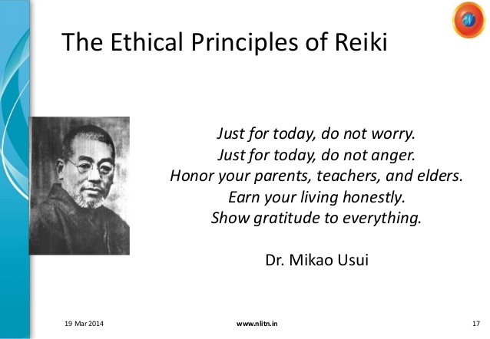

Prohibited Conduct within Drawing Down the Moon System of Reiki classes, workshops, and community events:
Prohibited conduct includes but is not limited to:
- Assaulting, harassing, intimidating, or threatening another individual or group. No Student shall use words that incite others to behaviour that is inappropriate to members of the DDTM Community
- Endangering the health or safety of others: No Student shall create a condition which endangers or potentially endangers or threatens the health, safety or well being of other persons.
- Disrupting DDTM activities: No Student shall disrupt a Class in such a way that interferes with the normal process of the session or the learning of other Students. No Student shall, by action, words, written material, or by any means whatsoever, obstruct DDTM Activities or DDTM-related Functions.
- No Student shall use DDTM materials or support services without authorization
- No Student shall make false accusations against any member of the DDTM community.
- Dissemination of Malicious Material: No Student shall disseminate or cause to be disseminated malicious or defamatory material or engage in activity which creates a social or academic climate that hinders or prevents the full participation of another person or group in the experience of Reiki within the DDTM System.
- Unfounded Allegations: No Student shall make any complaint against any other member of the DDTM Community or cause any steps to be taken concerning any other member of the DDTM Community unless the Student believes, on reasonable grounds, that the other member of the DDTM Community has committed an offence.
- Misuse of Confidential Materials: No Student shall procure, distribute, or receive any DDTM material such as class manuals, DDTM Dojo Websites, or DDTM Facebook groups or the contents thereof from any source without prior and express consent of the Drawing Down the Moon System of Reiki Founder, Lisa Ayres.
- Supplying false information to DDTM or forging, altering, or misusing any DDTM document or record.
- Failing to comply with a disciplinary measure or disciplinary measures imposed by DDTM official(s)
- Participation in an Offence: No Student shall counsel or encourage or knowingly aid or assist, directly or indirectly, another person in the commission of any offence.
- Bribery: No Student shall offer or provide a monetary or other benefit to any member of the DDTM Community for the purpose of gaining educational or title advantage.

Prohibited Conduct within Drawing Down the Moon System of Reiki practicum activities:
The following behaviour by any Student in a Practicum Agreement is unprofessional conduct, and an offence under the DDTM Code of Conduct:
- all attempts at deliberately falsifying client or pupil records including forging Instructor signatures
- falsifying financial records related to client treatment procedures or services
- misrepresenting client treatment, instruction, or services to officials of DDTM or to third parties, such as insurance carriers
- careless or negligent behaviour resulting in unnecessary physical and/or mental harm to clients or pupils
- obtaining or attempting to obtain favours, gifts, payments, pharmaceuticals or other consideration from pupils, clients or third parties
- representing one's education, qualifications or competence in a way that is false or misleading
- operating outside of your scope of practice

http://www.reiki.ca/ethics.htm:
14. Teaching members should not encourage the practice of Reiki by persons who are not competent or who have insufficient training or certification. They should not grant certificates of attendance or competence to anyone whose skills and/or ethical conduct they have a valid reason to doubt. Teaching members should report any such cases to the CRA.
15. Members are responsible for reporting any member of the CRA who does not respect this code of ethics. This requirement aims to ensure the protection of the public interest and also to protect the good name and professional reputation of the CRA.

Disciplinary Measures:
Disciplinary Measures that may be imposed by Drawing Down the Moon and it's Kyoushi include but are not limited to:
- Written warning or reprimand
- Payment of costs or compensation for any loss, damage or injury caused by the conduct
- Issuance of an apology, made publicly or privately
- Restriction or prohibition of access to, or use of, DDTM materials, services, activities, or programs
- Loss of fees
- Exclusion: restricts the Student's presence at and participation in any Class, DDTM activity or Student affair for a specified period of time. No fees will be returned.
- Suspension: requires a Student to withdraw completely from DDTM, their contract with DDTM, and from all DDTM Activities for a specified period of time. No fees will be returned.
- Expulsion: requires a Student to withdraw completely from all DDTM activities and removes all rights, privileges, and accesses for an indefinite period of time. The Student shall not be permitted to return to the community, nor granted access to any support materials or groups without the approval in writing of their Kyoushi in consultation with DDTM. Such approval shall not be given before the expiry of five years. No fees will be returned.

The member understands that if they transgress the Code of Conduct their membership in the DDTM Alumni will be permanently withdrawn without any refunds of any kind. The member also understands that if they are withdrawn from DDTM Alumni membership and they refuse to acquiesce to the withdrawal, DDTM maintains the right to take legal action against the ex-member, and the ex-member will be fully responsible for all costs.
Signed this _____ day of ______________ in the year _________ by:
Print Name | Signature

